Anemometer Google Play apps
Your cell phone with the help of instaliranh appropriate application can be very useful measuring device. In this tutorial you will learn how to do it.

Instructions
Go to the Google Play websit https://play.google.com/store
In the search box type in Anemometer and press ENTER (or magnifying glass)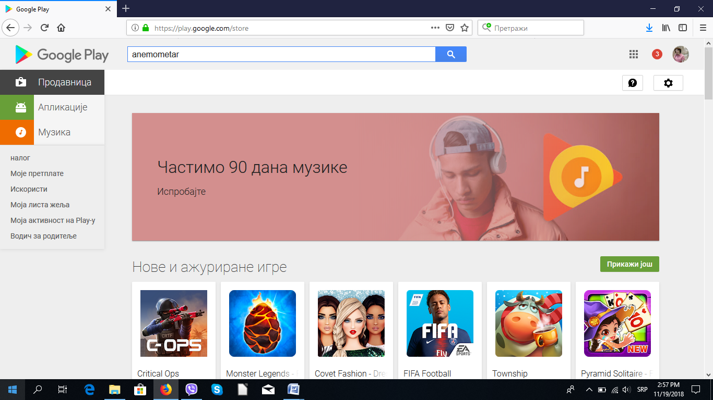

Look on your screen after this step:
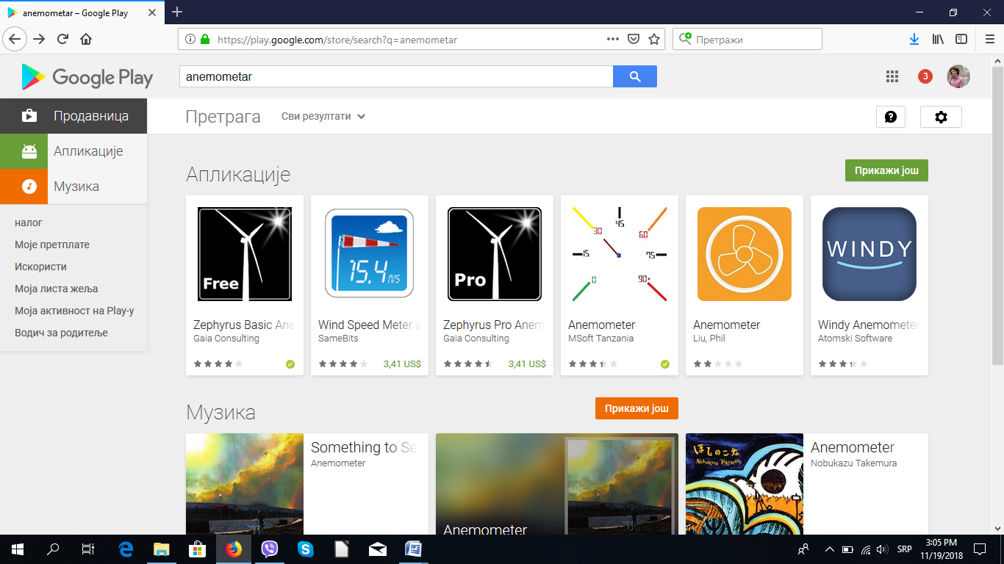

Select a free app anemometer:

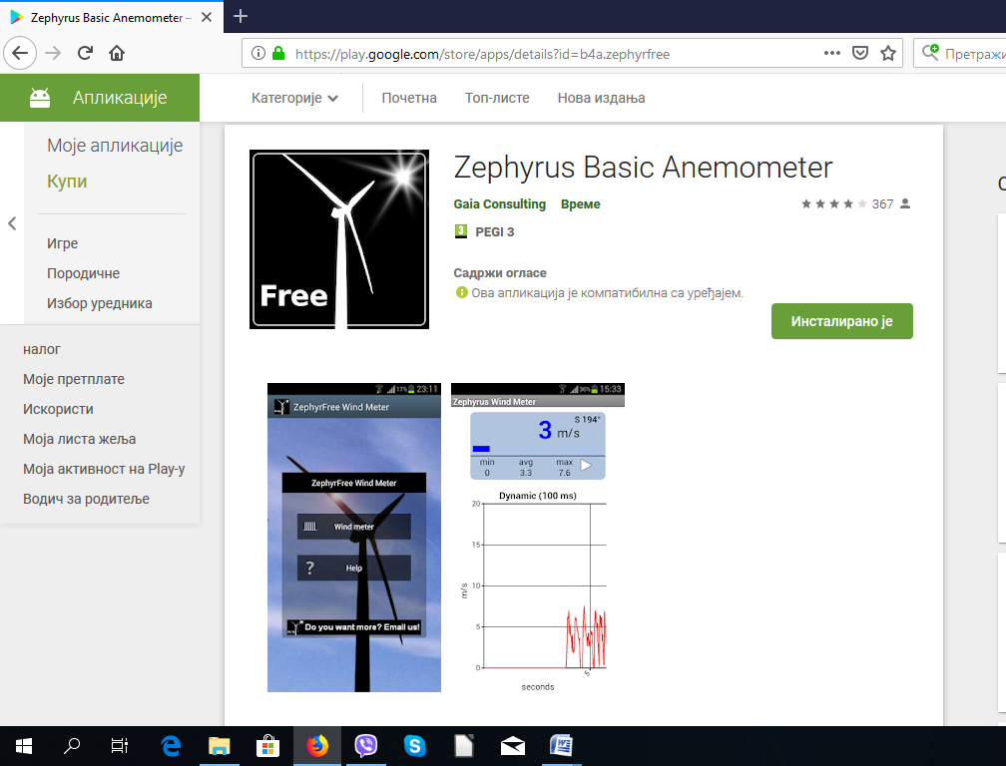

After installation, your mobile phone is ready to measure wind speed.

