Workshop - Make your windsock!

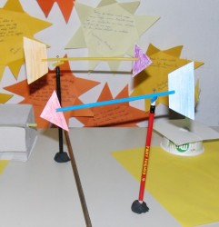
Wind plays a very important role in many of the things we plan to do outdoors. Also, depending from which direction the wind blows, it can be determined what will be the weather! For example, in our region, northern wind directions brings colder weather than that blows from the south. How would you and you could not tell from which direction the wind blows, with a little effort, you can make your windsock - meteorological instrument for determining the direction of the wind!

The materials needed to create a wind vane:
- Plastic container of ice cream
- Scissors
- Markers
- straw (plastic tube)
- Adhesive Tape
- pins
- Pencil with a rubber band at the top of
The plastic container marker pen, draw a triangle and a rectangle of equal size. Cut out with scissors. Then, take a straw and snarled the two-inch on both ends toward the middle. Care should be taken: the notch on the tube should be at the same level. In a comma placed a triangle cut out of plastic containers, and in the second comma rectangle so it tightens the tape that would not have fallen. Then straw pierced pins middle, so that triangle and rectangle are in the direction of a pin. Whole straw with a Pin stab the eraser on a pencil. So your weather vane will rotate around the pin.
Weather vane placed outdoors, on the terrace or in the courtyard. Watch as they rotate. You'll see that you'll always be a triangle to show the direction from which the wind blows

