Workshop - How fast the wind is blowing?

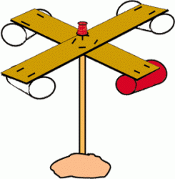
Make a meteorological instrument - anemometer by which you will determine how fast the wind is blowing.
For making the anemometer required is as follows:
- hard board
- Scissors
- Staple
- 4 small plastic cups
- pins
- The adhesive tape
- with a pencil eraser at the top
Made of cardboard cut out two equal rectangle width 3-4 cm and a length of 20 centimeters. Cardboard must be as tougher in order not to bend. Rectangles that you cut put one over the other so that you get a "baptism" which will be all four arms of equal length. The middle of the rectangle, at the touch attach a stapler or tape. At the top of each "baptism" or sticking zaheftaj one plastic cup so that they are open in the same direction (see figure). Then all of a Pin fastened together in the middle "baptism" for the eraser on a pencil to the anemometer was free to rotate.
Anemometer should be mounted at an open place where the wind blows. The faster the anemometer rotates, the higher the wind speed. To be able to monitor how fast the wind is blowing, can one glass mark by becoming the paint marker. Thus you will be able to count how many times the anemometer turned in a certain time and thus keep track of when the wind blows faster, and when slower.

